**Brooklyn torah gazette**

**For parshas tzav 5783**

Volume 7, Issue 29 (Whole Number 336) 10 Nissan 5783/ April 1, 2023

**Printed L’illuy nishmas Nechama bas R’ Noach, a”h**

For a free subscription, please forward your request to [***keren18@juno.com***](mailto:keren18@juno.com)

**Naftali Horowitz and**

**How to Lead a Life of**

**Wealth and Success**

**By Daniel Keren**

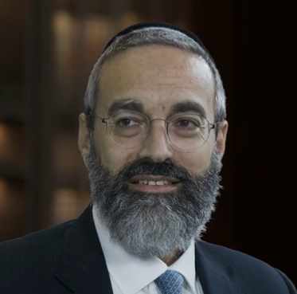

**Naftali Horowitz**

One can be a highly respected Managing Director at the world renowned financial firm JP Morgan, serving as a financial advisor to the wealthy and yet not compromise on one’s Torah values as epitomized by the inspiring story of Naftali Horowitz.

Recently Naftali as he prefers to be called was the featured speaker at the Living L’Chaim, a popular Jewish podcast’s first **Maximizing Your Money - Kosher Money Event** that was held at a Young Israel in Long Island last month. He addressed the topic of “**Wanna Invest Successfully**” and offers Five Principles that won’t make you rich overnight, but will help you develop wealth over a steady course of several years.

**A Lot of Money Can’t Make You Happy**

Man (i.e., Jewish people in particular) does not live by bread alone and a few years ago Naftali Horowitz authored an insightful book published by ArtScroll titled “You Revealed – A Torah Path to a Life of Success.” Ironically, Naftali has met many of his wealthy clients whom he offers financial guidance and who are among the most-unhappiest individuals in the world.

Getting back to his recent Kosher Money Event address, Naftali Horowitz spoke about the common mistakes that most people make when trying to invest in the stock market. He brings about 25 years of experience and noted the fact that a few years back he wrote the curriculum for a New York University (NYU) course on behavioral finance, a cross section between psychology and finance that basically analyzes the behavior of investors in the market.

**Most of His Job is to Serve as a Psychologist**

**and Stop His Clients From Hurting Themselves**

The course tries to understand why investors make the decisions that they do and why they continually make serious mistakes. Naftali Horowitz noted that 90% of his job as a financial advisor to the wealthy is to serve as a psychologist and help his clients by stopping them from hurting themselves financially.

He emphasized that the main principle in investing is to always buy low and sell high. Unfortunately, Naftali Horowitz explained that most people do the opposite. To view or listen to the entire one hour and one minute Kosher Money Event lecture you can google **Wanna Invest Successfully - Keep These 5 Things in Mind - Naftali Horowitz or** <https://youtu.be/1TV4Nu_wXE4>

If you like this fascinating podcast, you might also want to view some other Naftali Horowitz interview podcasts such as: **Inside ArtScroll Episode 11 – Naftali Horowitz** and The Story of Naftali Horowitz – Meaningful People or <https://youtu.be/kW4G4fYWjJY>

***Reprinted from the March 24, 2023 edition of the Jewish Connection.***

**Rav Avigdor Miller on**

**Jewish Wives and Irish Wives**

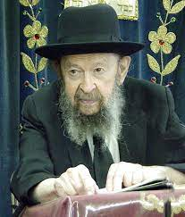

**QUESTION:** I know a very religious man who works all day and then he spends his nights in the beis medrash learning and he doesn’t give a lot of time to his wife and children. And his wife and children complain about it. What do you think about that?

**ANSWER:** Let’s talk about a not very religious man.  Let’s say Mr. John Howards.  He’s an Irishman, let’s say, who lives on East 16th Street.  I never checked that it’s so, but imagine so.

Mr. John Howards has to get up early in the morning.  He’s not a professor and he has to do hard labor to pay his rent and therefore he’s on the job early in the morning.  When he comes home, he’s pretty tired.

Now he can’t sit at home and just waste his life, so in the evening he goes to a saloon; there’s a bar-room on Avenue N and Coney Island Avenue.  Let’s imagine there’s a bar-room there.  And there he has friends, Irish friends of his, and they sit together and drink a little bit and play cards; nothing so terrible.  And then he comes home late at night.

Now his wife might complain.  She says, “Look, a man like you, you’re busy all day long. Why don’t we have a little of your company?”

So what does he answer? “What do you mean company?” he says.  “That I can’t live?  Don’t forget I’m giving for you my whole life.  I’m sacrificing.  I get up early in the morning.  I work all day long. So, what do you want of me?  I need some recreation.”

So, an Irish wife understands that. Her husband needs some recreation. She’s happy he doesn’t bum around.  He’s not immoral.  Sometimes he gets a black eye in the bar-room.  Sometimes he drinks so much that they find he doesn’t get home at night.  In the morning he’s still sleeping on the sidewalk outside the bar-room.  That’s alright by them. He can boast about it too.  He says, “Boy, did I drink a lot last night!”  He tells it to all his friends.  No shame.

I pass by sometimes early in the morning and I see them lying on the ground; well-dressed Irishmen. He’s not ashamed.  A little later in the day he’ll get up. And he’ll boast about it to his grandchildren.  “Boy,” he says, “That day, I took a lot.” His wife won’t blame him much.

**A Man Who Doesn’t Go to a Bar-Room**

But here’s a man who doesn’t go to a bar-room.  He goes to a beis hamedrash at night and he’s learning Gemara.  He doesn’t get any black eyes in the beis hamedrash.  You never find him asleep on the sidewalk outside the beis hamedrash.

What do you want of him?  He’s working all day long to support you. Isn’t it a wicked thing for a woman to claim, “My husband neglects me.  He’s a religious man and he neglects me”?

What do you mean he neglects you? He works all day long to pay the bills.  Besides the fact that when he’s sitting in the beis hamedrash and learning, it’s you learning because a wife gets 100% partnership in her husband’s learning.  And therefore, it’s a silly woman who makes such complaints.  On the contrary, she should encourage him.

**Women Need the Zchus (Merit) of Torah Too**

Now an Irish woman wouldn’t encourage a husband to go to the bar-room, but at least she keeps quiet.  But if your husband is going to the beis hamedrash it’s a zechus for you. נשים במאי קא זכיין – how are women zocheh?  After all, women need the zchus (merit) of Torah too.  If they send their husbands to learn and they send their children to learn, that’s one of the merits of a kosher Jewish wife and she has a share in the Torah.

*Reprinted from a recent email of Toras Avigdor (based on Tape #475 – September 1983 lecture.)*

**The Eternal Aspect of a Jew’s Todah (Thanksgiving) Offering**

**From the Teachings of the Lubavitcher Rebbe**

**Rabbi Menachem Mendel Schneerson, Zt”l**

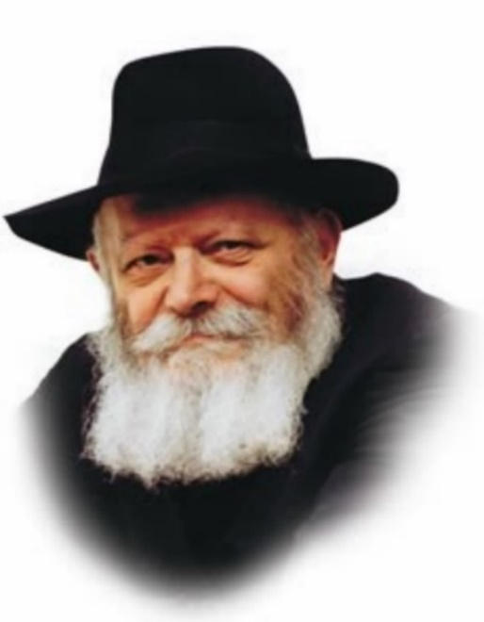

In this week’s Torah portion, Tzav, we read “And the fire on the altar shall burn on it; it shall not go out. The Kohen (priest) shall kindle wood upon it every morning. (Lev. 6:5)”

The fire on the altar in the Sanctuary and later in the Holy Temple was a G-dly fire that burned whether wood was added or not. What was the purpose of adding the wood? What can we learn from this?

Every one of us is a Holy Temple. At our spiritual center, our altar, there is a G-dly fire that can never be extinguished, this is our neshama, our G-dly soul.

**The Folly of Living One’s Life on Auto-Pilot**

One may mistakenly think, “I am a Jew at heart, isn’t that enough? I will set myself on auto-pilot, my current direction is good enough for me.”

To this the Torah says, the Kohen must kindle wood on it every morning. You must invest your physical self, possessions and time to develop and grow your fire every day.

We can take a lesson from this for our personal relationships. One may mistakenly think, “they know how I feel, that should be enough.” Or, “I give them everything they want/ask for, that should be enough.” To this the Torah says “The Kohen must kindle upon it wood every morning.” You must invest your physical, mental and emotional self into the relationship regularly.

**The Most Special of all Sacrifices –**

**The Todah (Thanksgiving) Korban**

Do not take your relationships for granted. Keep adding wood to your fires.

Our portion also speaks of several different sacrifices that were offered in the Sanctuary and later in the Holy Temple. There is one offering that is more special than all the rest, the Korban Todah, the thanksgiving offering. What is unique about this offering is that while other personal offerings, such as sin and guilt sacrifices, will cease to be offered when Moshiach comes, the thanksgiving is the only personal offering that will continue even in the times of Moshiach. What is unique about the Todah that it is eternal?

**A Life Permeated by G-dliness**

Moshiach will usher in an era when G-dliness will permeate our lives openly. Death, sickness, sin, etc., will cease to exist. With no transgressions, the sin and guilt offerings become obsolete.

The Todah, on the other hand, will continue. While “todah” means thanks, it also has the same root as the Hebrew word “modeh,” to acknowledge, i.e., validation of the other. And in a way, that is what giving thanks is all about – recognizing the other.

**Why the Todah is Eternal**

When Moshiach comes, we will have no problems or suffering to focus on. When you think about yourself there is no room for joy or anyone else; your problems take over your every thought. However, if you can find a way to focus on others, you will feel joy, a taste of Moshiach. This is why the Todah is eternal. We will acknowledge G-d’s hand in our successes and be able to acknowledge the other.

*Reprinted from the Parshat Tzav 5782/2022 edition of L’Chaim, a publication of the Lubavitch Youth Organization in Brooklyn, NY. Adapted by Rabbi Yitzi Hurwitz from the teachings of the Lubavitcher Rebbe, yitzihurwitz.blogspot.com. Rabbi Hurwitz, who is battling ALS, and his wife Dina, are emissaries of the Rebbe in Temecula, CA.*

**Rabbi Berel Wein on**

**Parshat Tzav 5783**

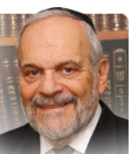

The parsha of Tzav more often than not coincides with the Shabat preceding Pesach – Shabat Hagadol, the “great Shabat.” At first glance there does not seem to be any inherent connection between the parsha of Tzav and Shabat Hagadol and Pesach. However, since Judaism little recognizes randomness or happenstance regarding Jewish life, and certainly regarding Torah itself, a further analysis of the parsha may reveal to us an underlying connection between Tzav and Pesach.

**The New Freed Slave Have Newfound Responsibilities**

I feel that this underlying theme lies in the description that the parsha contains regarding the consecration of Aharon and his sons as the priests and servants of G-d and Israel. Judaism teaches us that freedom equals responsibility. Freedom without limits or purpose is destructive anarchy. The entire narrative of the Torah regarding the construction of the Mishkan and the institution of public worship/sacrifices come to emphasize to the freed slaves from Egypt their newfound responsibilities.

The rabbis cogently and correctly defined freedom in terms of obligations and study of Torah, as opposed to the alleged freedom of hedonism. The consecration of Aharon and his sons coinciding with the consecration and dedication of the Mishkan itself brought home to the Jewish people the requirement of community service and national unity.

**The Jewish Need for Aharon and the Mishkan**

Look at the freedom movements that have arisen in the Middle East over the past few years and the chaos and deaths of tens of thousands of people that followed in their wake. The inability to create unity, to develop a moral and tangible national goal mocks all pretenses of positive freedom. Without Aharon and the Mishkan the promise of the freedom of Pesach would have remained permanently unfulfilled.

Part of the lesson of the Great Shabat is that without Shabat, Jewish freedom is only an illusion. Shabat is truly the epitome of freedom. The absence of workday activities, the sense of family and friends, and of the contentment that Shabat engenders all combine to create a vision of true freedom that is attainable and real.

The Great Shabat that precedes Pesach gives it its true meaning and places the anniversary of our freedom from Egyptian bondage into holy perspective. Freedom to toil 24/7 is only a different form of slavery. When Saturday looks like Tuesday but only more so since school is out and the burdens of carpooling and “having a good time” are even greater, then that cannot even remotely be related to true freedom.

**The Ultimate Miracle of Shabat Hagadol**

In reality every Shabat is the Great Shabat and the Shabat preceding Pesach is even more so. Shabat Hagadol represents the miracle that blessed our forefathers in Egypt when they took the Paschal lamb and the Egyptians did not object. But the true and ultimate miracle of Shabat Hagadol is Shabat itself. It has preserved the Jewish people throughout the ages in the face of opposing innumerable odds and challenges. It is in the realization of our freedom that we are able to properly appreciate and give tribute to Shabat - Shabat Hagadol, the Great Shabat that we now commemorate so joyfully and gratefully.

Shabat shalom

Pesach kasher v’sameach

*Reprinted from the current website of rabbiwein.com*

**The Life and Teachings of Reb Nochum of Chernobyl**

**By [Boruch Twersky](https://www.chabad.org/search/keyword_cdo/kid/20226/jewish/Twersky-Boruch.htm" \o "Browse more articles by Twersky, Boruch)**

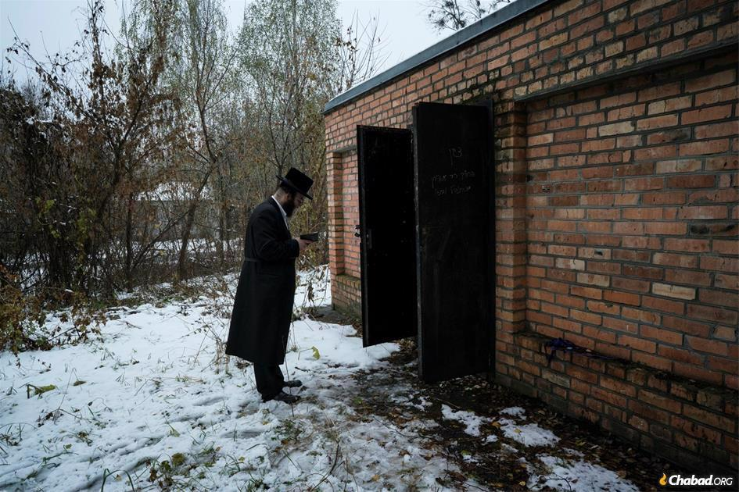

**The resting place of several early Rebbes of Chernobyl, now within the Chernobyl Exclusion Zone, where public access and inhabitation are restricted due to radioactive contamination from nuclear fallout (photo: Pierpaolo Mittica/Parallelozero).**

Rabbi Menachem Nochum Twersky (1730 - 1798) was a student of the Baal Shem Tov and the Maggid of Mezeritch, and the author of the Chasidic work Meor Einayim. In 1773, he initiated his own Chasidic court in Chernobyl, founded on the pillars of humility and sincerity (*temimut*).

Upon his passing, he was succeeded by his son, Reb Mordechai. Each of Reb Mordechai’s eight sons branched out and founded a Chasidic court of his own. This is the origin of several Chasidic courts of our generation, such as Skver, Rachmastrivka, Tolna, Trisk, Honisteipel, and Chernobyl.

**A Classic Teaching**

Many people wonder: Why do we all have such different fates? Some are wealthy, some are poor. Some have blissful home lives, while others struggle. There are health issues that some have to deal with, and others don't. Why?

Reb [Nochum](https://www.chabad.org/library/bible_cdo/aid/15764/jewish/Nachum-Nahum.htm" \o "Nachum (Nahum)) taught that the purpose of life is to recognize G‑d, and to facilitate that goal [G‑d](https://www.chabad.org/library/article_cdo/aid/433240/jewish/God.htm) provides each individual with the circumstances that will help them attain that awareness. For some, it is easier to discover G‑d when wealthy; others find Him more easily when they struggle with poverty.[1](javascript:doFootnote('1a5128237');)

“Some have wisdom, some strength, some wealth, and some poverty. This is all because G‑d sees, with His wisdom, what each person needs, that this person needs specifically that situation in order to come close to Him. Others have other life experiences [because those are the experiences that they need to become close to Him].”[2](javascript:doFootnote('2a5128237');)

All of Reb Nochum Chernobler's teachings, recorded in Meor Einayim, are based on the lessons he learned from his masters, the Baal Shem Tov and the [Maggid of Mezeritch](https://www.chabad.org/library/article_cdo/aid/4961773/jewish/The-Maggid-of-Mezritch.htm). This particular lesson, however, he had seen from his own life experiences, even before hearing it from his teachers.

**A Lesson From Life**

Reb Nochum had a traumatic childhood and continued to suffer many hardships throughout his life.

As a young child, he was orphaned of both of his parents and subsequently raised by his impoverished aunt and uncle. Being an orphan is one tragedy, poverty is another, and to top it off, he was mistreated.

Once, his aunt served toast and cream to her children, but to little Nochum, she gave plain, dry toast. Nochum complained that he also wanted cream, and for that his aunt locked him in a room. There was a bucket in that room filled with white paste. Nochum thought it was cheese, and he put some on his toast. But then he couldn’t eat his toast, because the white spread was cement. This experience taught him, he later said, that when one takes what isn't his, he loses what is his.

His aunt and uncle sometimes gave gifts to their children (such as a penknife, a watch, etc.) but they never gave anything to Nochum. Somehow, however, Nochum always attained the same items as his cousins. The teacher at school suspected that he was stealing, because how else did he get those gifts? When he spoke with Nochum about it, Nochum replied, "My father gives it to me."  
The teacher was astonished, "What are you saying? Are you imagining things? You don’t have a father!"

"I wasn't referring to my biological father," he replied. "I meant my Father in Heaven gives me these gifts. I ask, and He gives me."

This didn’t sound right to the teacher, and he shared his suspicions with the uncle. They decided to test it. The uncle gave a coin to each one of his own children, and nothing to Nochum.

Nochum ran to the synagogue, and the uncle and the teacher followed stealthily behind. They watched as Nochum put his head in the aron kodesh (holy ark) and sobbed, "Father in heaven, I also want a coin. I want a coin like my cousins have…" He repeated this prayer many times, and then they all heard a coin drop. Nochum picked it up. His prayers were answered.

This is a remarkable story of faith, and it is certain that Nochum's unfortunate circumstances spurred him to enhance his connection with G‑d, embodying the verse in Psalms, "My father and my mother abandoned me, and G‑d brought me in."[3](javascript:doFootnote('3a5128237');)

**With the Baal Shem Tov**

The Baal Shem Tov had heard about the holy young man, and sent his students to ask Reb Nochum to come see him. Reb Nochum replied, "I work as a teacher; I have students; I can't leave them." Only when the Baal Shem Tov sent a substitute teacher to fill in for him, did Reb Nochum agree to accompany the students back to their master.

He arrived while the Baal Shem Tov was eating a meal with his students, celebrating some kind of holiday. The Baal Shem Tov greeted Reb Nochum and invited him to join them at the meal. Reb Nochum stood there, unsure how to proceed. It wasn't proper to eat a meal while wearing a coat, but he didn’t want to take his coat off, because his clothes were ripped around the shoulders. (He was very poor and he couldn’t afford to mend his clothes. He was fortunate that he even owned his own coat. For a long time, he and his wife, Sarah, had shared a single coat, which they took turns wearing.)

The Baal Shem Tov repeated, "Wash your hands and join us at the meal," so he did.

The Baal Shem Tov invited Reb Nochum to be his guest in his home, and warned his wife, "Be wary of this man, he is a great ganev (thief)."

After observing Reb Nochum's ways, she asked her husband, "Why did you call him a thief? He’s a great *tzaddik*!"

The Baal Shem Tov replied, "He wants to steal the entire Gan Eden for himself, with his good deeds."

Some say that the Baal Shem Tov added, "And he wants to steal all the holy souls that are in heaven, and have them as his descendants."

**A Maggid**

Reb Nochum spent two prolonged periods of time with the holy Baal Shem Tov.[4](javascript:doFootnote('4a5128237');) After the Baal Shem Tov's passing, he became a student of Reb Dov Ber, the Maggid of Mezrtich.

When he returned home after his first stay with the Baal Shem Tov, Reb Nochum began serving as a maggid (a preacher who would regularly inspire the masses with teachings about ethics, morality and religious observance).

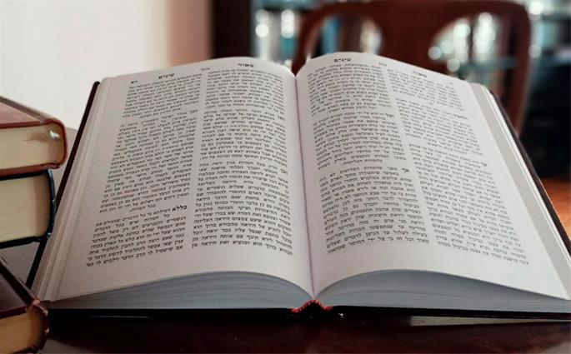

**The teachings recorded in Meor Einayim are based on the lessons Reb Nochum learned from his masters, the Baal Shem Tov and the Maggid of Mezeritch.**

The introduction to Meor Einayim refers to him as "Reb Menachem Nachum, the Maggid of Chernobyl and other holy communities … With his talks … he brought many people to *teshuvah*, and to serve G‑d, so that the awe of G‑d shall be on their faces. He drew them with cords of love, with holy ideas – sweet like honey … mostly based on the teachings of the Baal Shem Tov. Every Shabbat … and every holiday … and sometimes on weekdays, he taught Chassidut, and he also taught Talmud and Jewish law…"

His speeches were highly effective, immediately having the desired effects. In fact, when Rabbi Levi Yitzchak of Berdichev met a particularly humble person and he asked him how he reached that level of humility, he was told, “I heard Reb Reb Nochum Chernobler quote the Mishnah, ‘Be very humble,’ and it changed me permanently."[5](javascript:doFootnote('5a5128237');)

**His Teachings**

Reb Nochum’s students wrote down what they heard, eventually culminating in a tremendous amount of handwritten pages which they asked Reb Nochum for permission to print. Reb Nachum went through the pile, page by page, and chose just one fifteenth of the material. He explained, "These are the lessons that I don’t remember teaching. That means it must have been the Shechinah (Divine Presence) speaking through me. I want only those lessons printed."

This is the holy book, *Maor* Einayim, one of the first Chassidic works ever printed.

Reb Nochum told people that it is worthwhile to study his lessons, even if they don’t understand them, because Moshiach will teach the same lessons.

**Divine Service**

Reb Yaakov Yosef of Polnoye (author of *Toldot Yaakov Yosef*) said that each [*tzaddik*](https://www.chabad.org/library/article_cdo/aid/2367724/jewish/Tzaddik.htm) has an area of expertise. Some *tzaddikim* excel in Torah study, some in passionate prayer, others excel in giving *tzedakah*, and so on. It is rare that a person can be outstanding in several ways. Of Reb Nochum, however, he said, "Reb Nochum isn't one *tzaddik*; he is like ten [*tzaddikim*](https://www.chabad.org/library/article_cdo/aid/2367724/jewish/Tzaddik.htm)," as he excelled in several aspects of Divine service.

**Excellence in**[**Tzedakah**](https://www.chabad.org/library/article_cdo/aid/3056/jewish/Charity-an-Anthology.htm)

Reb Nochum heard about a city that couldn’t afford to build a mikvah. He traveled there and announced, "Whoever pays to build a [mikvah](https://www.chabad.org/theJewishWoman/article_cdo/aid/323424/jewish/Mikvah.htm), I will sell him my portion in the World to Come."

In that city lived a wealthy person who never gave tzedakah. He realized that this was a golden opportunity to earn his place in paradise. He put down the money for the construction of the mikvah, plus more to pay for the heating of the mikvah for many years. Reb Nochum wrote up a document stating that he sells his portion of the World to Come to the benefactor, and it was signed by witnesses.

People asked Reb Nochum why he agreed to give away his eternal reward, and Reb Nochum explained that this is his way of giving charity. "I don’t have money. My only asset is my Divine reward. So, I gave that away for G‑d's honor. This is how I fulfill the commandment in the Shema to serve G‑d bechol meodecha, with all your means."

Actually, Reb Nochum earned a nice salary serving as a maggid, but nevertheless, he and his wife were always poor, as he gave most of his money to the destitute. .

In particular, Reb Nochum excelled at the mitzvah of *pidyon shevuyim*, raising money to release people from prison. When Reb Nochum himself was imprisoned for a prolonged period, many of his followers were surprised that his merits of saving people from jail didn’t protect him. But Reb Nochum explained that the imprisonment was for his benefit, because now that he knows how painful it is to be a prisoner, he will perform the [mitzvah](https://www.chabad.org/library/article_cdo/aid/1438516/jewish/Mitzvah.htm) of pidyon shvuyim in an even better way.

**Passionate Prayer**

Reb Nochum teaches us the recipe for deriving pleasure when praying and when serving G‑d.

"When one studies [Torah](https://www.chabad.org/library/article_cdo/aid/1426382/jewish/Torah.htm) and prays with joy, fiery passion, love and fear, the pleasure will come. Because at first, one must toil in G‑d's service [to say the words joyously, and with excitement, with love and fear] … and then the pleasure always comes in the midst of his service."[6](javascript:doFootnote('6a5128237');)

In Hayom Yom, the sixth Lubavitcher Rebbe, himself a descendant of Reb Nochum, wrote:

"My father [the Rebbe Reshab] writes in one of his discourses, 'When one's soul derives pleasure from G‑dliness, one can become fat just from that. They say about Reb Nochum of Chernobyl that he became portly from saying *amen* yehei shemei rabbah."[7](javascript:doFootnote('7a5128237');)

**Devotion to Shabbat**

One Shabbat, Reb Nochum complained that he couldn’t feel the holiness of Shabbat in one of his feet.

His young son Mordechai told him that one of his socks had become dirty in the mikvah on erev Shabbat, so he had handed him a weekday sock.

“You have consoled me,” replied Reb Nochum, realizing that it wasn't due to sin that he didn’t feel the holiness of Shabbat.

On another occasion, Reb Nochum woke up in the middle of the night, on Shabbat, and wanted to leave the house. Everything was dark, however, and he was forced to grope in the darkness. He later asked his host why he hadn’t prepared tall candles that would last through the night. His host was stunned, because there was a tall, lit candle in the home.

They later discovered that the candle had blown out and the non-Jewish maid had relit it. Since the flame was lit on Shabbat, Reb Nochum wasn’t able to see its light.

**Excellence in Humility**

A group of chassidim were sitting together, discussing their Divine service, and with broken hearts they lamented, "We have no good deeds. The only good thing we have is that we have a great rebbe." With this thought in mind, they traveled to Chernobyl to be with Reb Nochum.

When they arrived in Chernobyl, they heard Reb Nochum saying to himself, "I’m very lowly. There’s nothing good about me. The only quality I have, which gives me some hope, is that I have good chassidim who come to me."

When Reb Nochum was in his late sixties, he was hit by a running animal and never recovered from his injuries. He was forced to borrow money to pay the doctors, and his colleague, the Alter Rebbe, raised money to help him pay off his debts.[8](javascript:doFootnote('8a5128237');)

Reb Nochum passed away on 11 Cheshvan, 5558 (1797), leaving behind a wealth of inspiration, good deeds, and teachings that continue to nourish the soul.

**FOOTNOTES**

[1.](https://www.chabad.org/library/article_cdo/aid/5128237/jewish/The-Life-and-Teachings-of-Reb-Nochum-of-Chernobyl.htm" \l "footnoteRef1a5128237) Meor Einayim, Matot.

[2.](https://www.chabad.org/library/article_cdo/aid/5128237/jewish/The-Life-and-Teachings-of-Reb-Nochum-of-Chernobyl.htm" \l "footnoteRef2a5128237) Meor Einayim, Likutim.

[3.](https://www.chabad.org/library/article_cdo/aid/5128237/jewish/The-Life-and-Teachings-of-Reb-Nochum-of-Chernobyl.htm" \l "footnoteRef3a5128237) Psalms 27.

[4.](https://www.chabad.org/library/article_cdo/aid/5128237/jewish/The-Life-and-Teachings-of-Reb-Nochum-of-Chernobyl.htm" \l "footnoteRef4a5128237) Corresponding these two times, Reb Nochum calls the Baal Shem Tov "my teacher" twice in his book, Meor Einayim (in Parshat Ki tisa).

[5.](https://www.chabad.org/library/article_cdo/aid/5128237/jewish/The-Life-and-Teachings-of-Reb-Nochum-of-Chernobyl.htm" \l "footnoteRef5a5128237) Avot 4:4.

[6.](https://www.chabad.org/library/article_cdo/aid/5128237/jewish/The-Life-and-Teachings-of-Reb-Nochum-of-Chernobyl.htm" \l "footnoteRef6a5128237) Meor Einayim, Yitro.

[7.](https://www.chabad.org/library/article_cdo/aid/5128237/jewish/The-Life-and-Teachings-of-Reb-Nochum-of-Chernobyl.htm" \l "footnoteRef7a5128237) [Hayom Yom, 15 Tammuz](https://www.chabad.org/therebbe/article_cdo/aid/3316676/jewish/15-Tammuz.htm).

[8.](https://www.chabad.org/library/article_cdo/aid/5128237/jewish/The-Life-and-Teachings-of-Reb-Nochum-of-Chernobyl.htm" \l "footnoteRef8a5128237) See Beit Rebbi Ch. 25, and Igrot Kodesh of the Alter Rebbe #27.

*Reprinted from the website of Chabad.Org Boston-born Boruch Twersky lives in Beitar, Israel, with his wife and 15 children. He has spent several years pursuing advanced Torah learning in kollel, authored many articles and translated a number of books. He is currently working on two books of his own.*